R.PRANUSHA

192111023

CSA1557-CLOD COMPUTING AND BIG DATA.

12) Create a Virtual Machine with 1 CPU, 2GB RAM and 15GB storage disk using a Type 2 Virtualization Software.

STEP 1:Create new virtualization

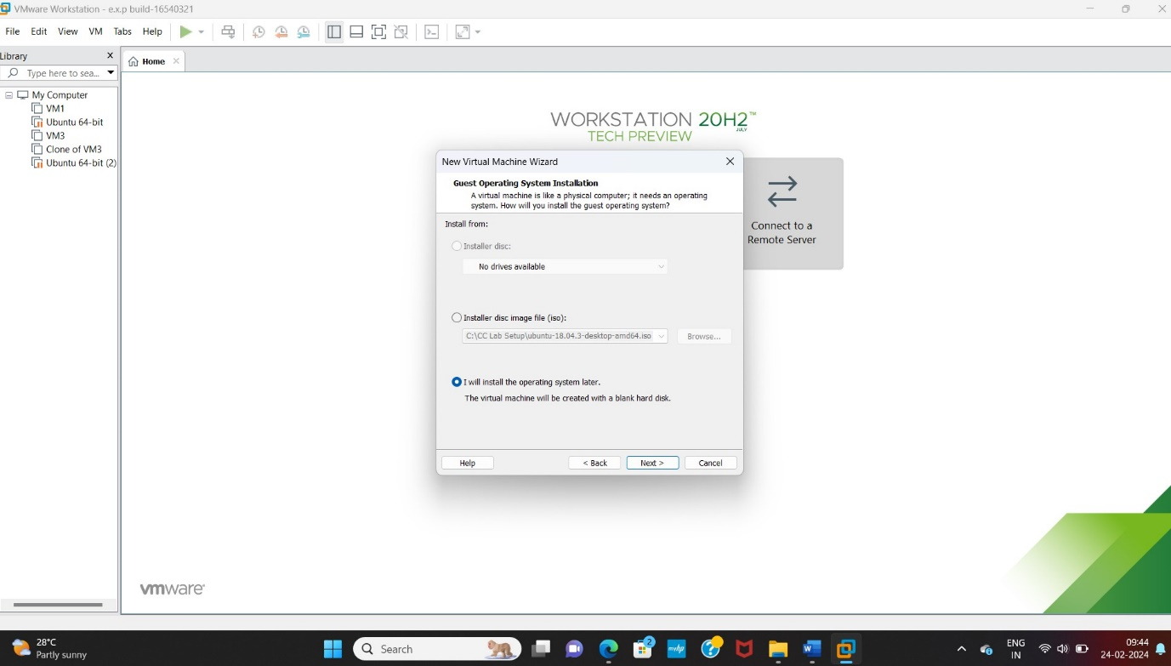

STEP 2:

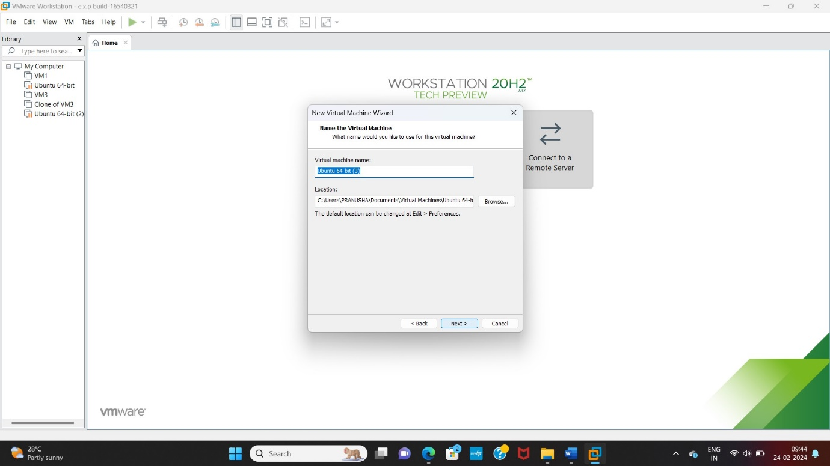

STEP 3: SIZE 15GB

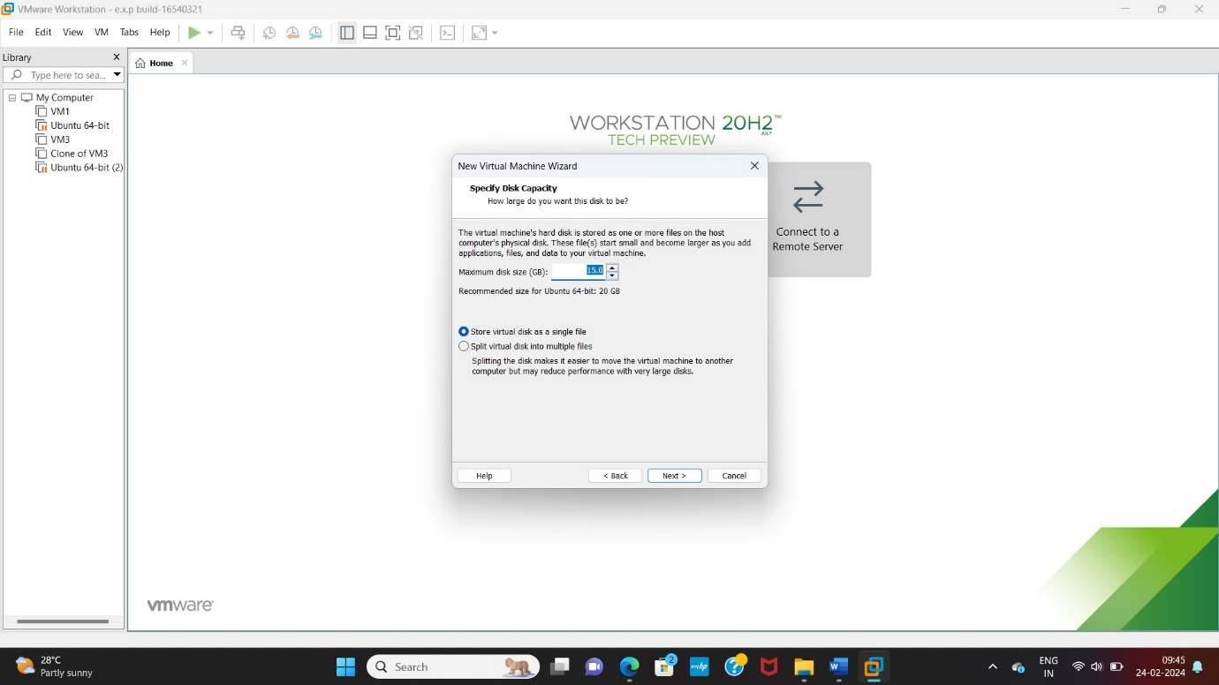

STEP 4:

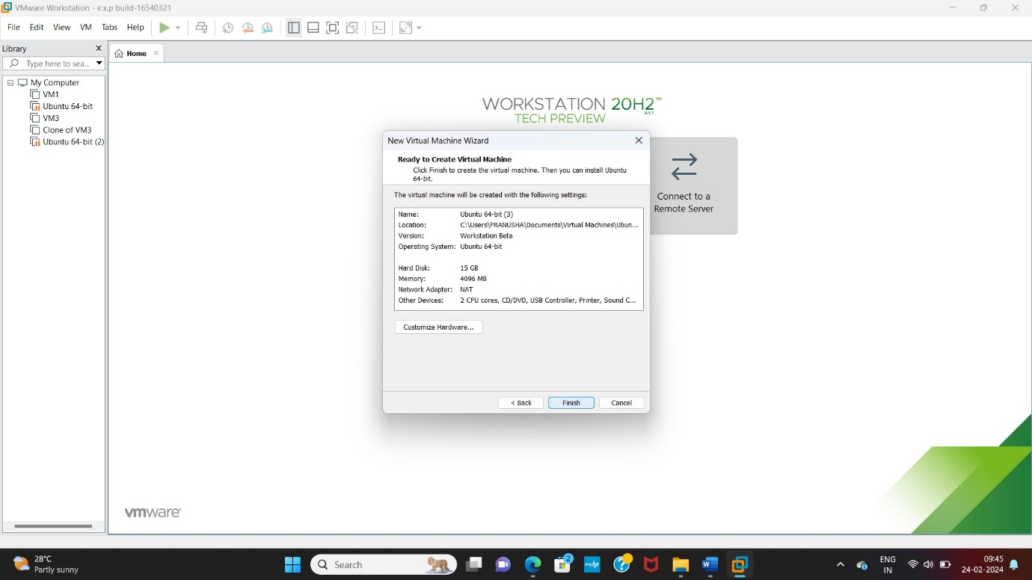

**STEP 5:**

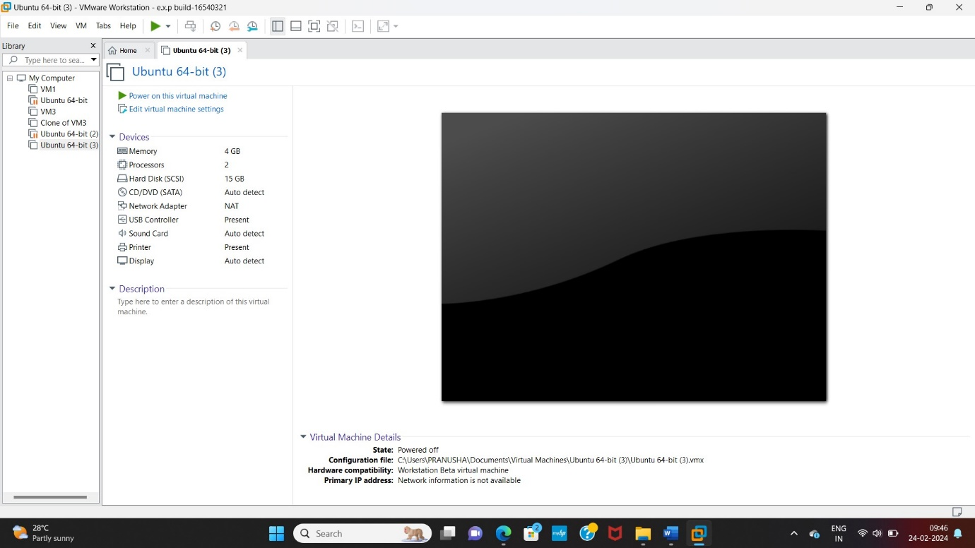

**STEP 6: Click memory and change size**

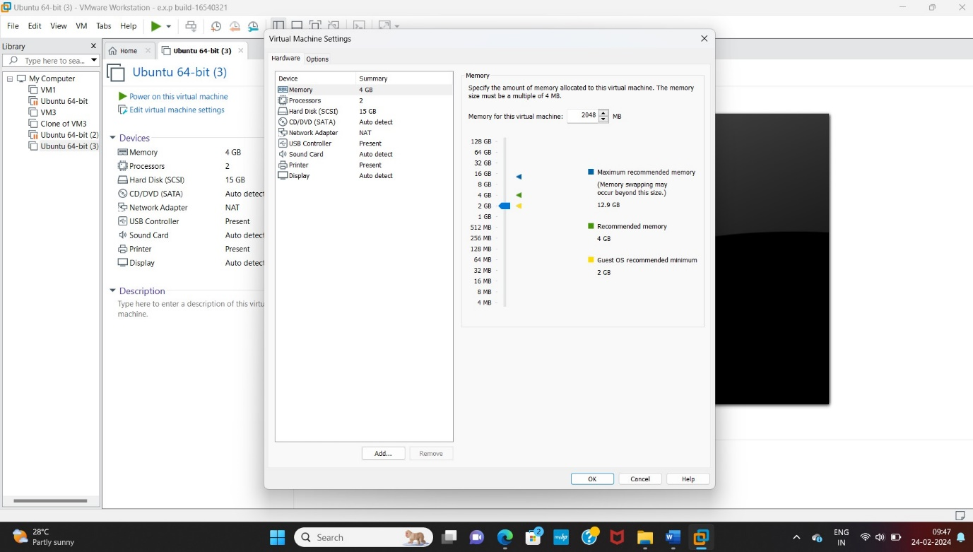

**Step 7:after changing size**

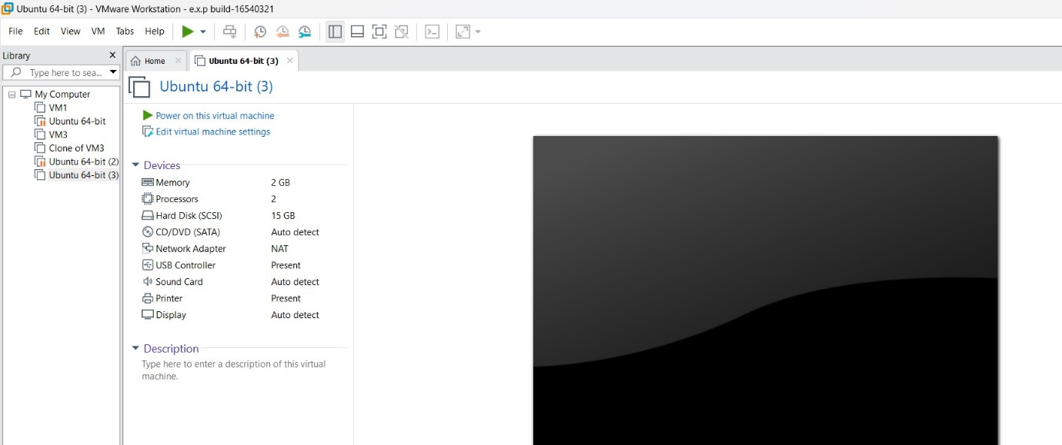

**Step 8:now change processor size**

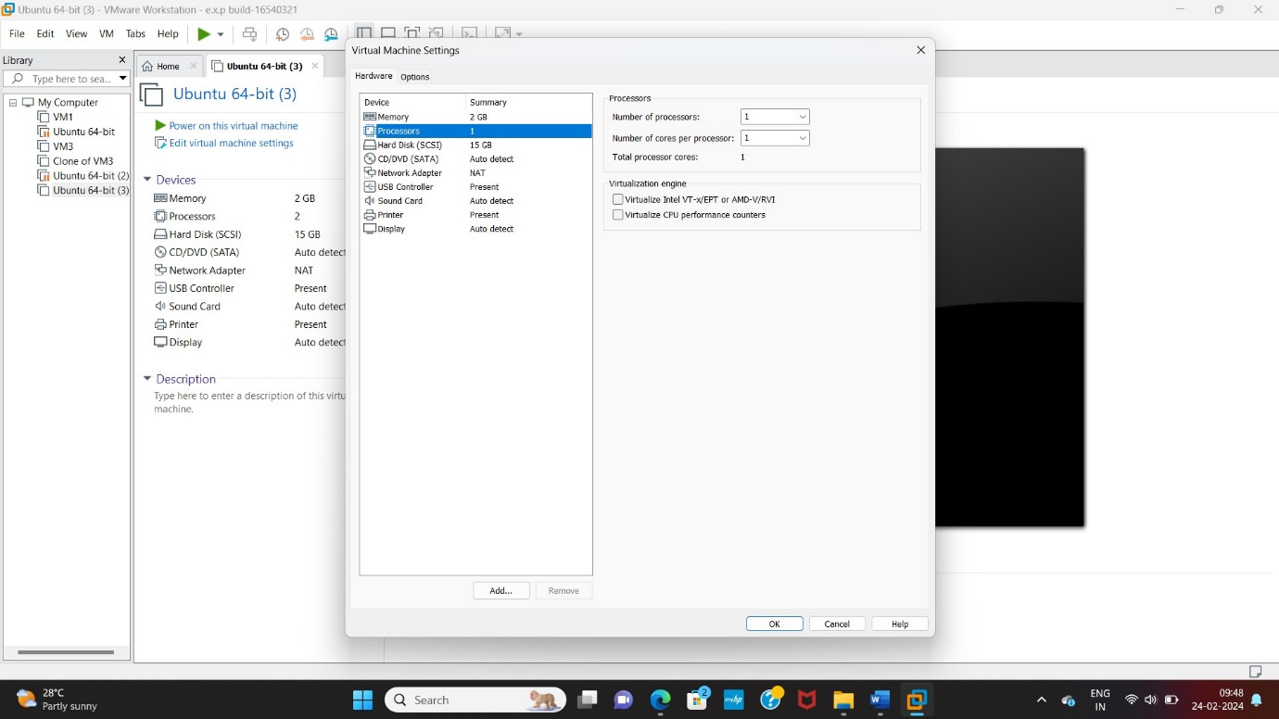

**Step 9: final output**

